Srinivas Tantravahi


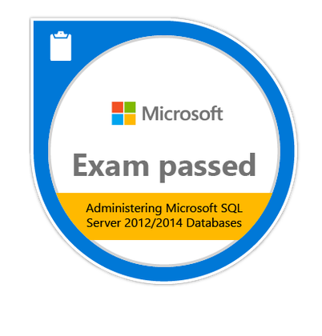
Generative AI Consultant | Agentic AI Architect | SRE Mindset
California, USA |Visa:H1b
571-595-3158
https://www.linkedin.com/in/tantraai/
17+ Years in Enterprise Engineering, Cloud, Reliability, and AI

Executive Summary
Senior technology leader with 17 plus years building and running mission critical platforms focusing on Generative AI and Agentic systems that automate work, improve decisions, and reduce operational cost.
Expert in enterprise RAG architecture, AI assistants, private LLM platforms, and production readiness. Strong mix of AI innovation and deep reliability engineering experience, making complex systems simple, stable, and scalable.

Core Skills
- Agentic AI architecture and multi step reasoning systems
- Enterprise RAG platforms with grounded responses
- ChatGPT driven business automation
- LangChain, modern orchestration frameworks, and tool-based agents like Flow wise, Crew AI, n8n, Zapier
- Google Vertex AI design and deployment
- Private AI platforms using Ollama and LM Studio
- Vector databases including Chroma DB and Pgvector
- FastAPI, Python, and scalable API services
- Prompt engineering, guardrails, and hallucination reduction
- SRE practices including SLI, SLO, incident reduction, and reliability design
- Cloud platforms, high availability systems, and automation
- Executive level AI consulting and solution design

Generative AI Engineer | Omnissa Mar 2024 – Present
- AI Content Approval Automation Platform
- Designed and deployed a cloud-native AI automation platform on n8n to streamline blog and social media content approval workflows.
- Integrated Large Language Models via Open Router APIs to automatically analyze content and detect approval signals such as “approve for article” or “approve for social.
- Built secure webhook-driven pipelines to receive content dynamically and trigger AI-based decision making in real time.
- Implemented structured JSON responses to enable downstream publishing systems and eliminate manual review steps.
- Architected a scalable workflow capable of handling long-form articles with embedded media while maintaining low infrastructure cost.
- Created a centralized tracking mechanism for published content to support future updates, auditability, and version control.

- Enterprise Resume Intelligence Platform
Architected and built a production ready hiring intelligence system that processes thousands of resumes, generates embeddings, ranks candidates, and enables natural language recruiter search. Reduced manual screening effort by over 70 percent and improved hiring speed.
- Agentic IT Operations Assistant
Designed an AI service assistant capable of asking dynamic follow up questions, identifying root causes, and guiding users through resolution paths similar to a tier one support engineer. Improved support response time and reduced ticket load.
- Secure Private AI Platform
Engineered an on-premises AI environment allowing organizations to run LLM workloads without exposing sensitive data externally. Enabled enterprise grade security while supporting advanced AI use cases.
- Multi Source Document Intelligence (RAG)
Developed systems that ingest structured and unstructured data, enforce context grounded answers, and significantly reduce hallucinations. Increased answer accuracy and user trust.
- Vertex AI Enterprise Architecture
Evaluated models, embeddings, and retrieval strategies to design scalable enterprise AI patterns ready for production adoption.
- AI Guardrails and Safety Framework
Implemented relevance filters, topic validation, and response controls to keep AI aligned with business intent and compliance needs.
Senior Database Engineer | Omnissa
- Managed multi-terabyte production databases supporting customer facing platforms with strict uptime targets
- Maintained 99.99 percent availability through proactive monitoring and reliability improvements
- Defined operational SLOs and reduced high severity incidents by improving alerting and automation
- Partnered with engineering teams to optimize performance and eliminate system bottlenecks
- Strengthened backup and recovery posture to ensure business continuity
- Championed SRE aligned practices across database operations
Senior Database Engineer | Sephora Mar 2020 – Mar 2024
- Supported high traffic retail systems handling large transaction volumes
- Improved query performance resulting in faster customer experiences
- Led capacity planning efforts to support rapid business growth
- Enhanced data protection strategies and recovery readiness
- Collaborated with cloud teams to improve infrastructure resilience
Senior Database Engineer | VMware Mar 2019 – Mar 2020
- Operated enterprise mobility platforms serving large global user populations
- Automated routine operational tasks which reduced manual effort and human error
- Resolved critical production incidents quickly, protecting service reliability
Maintained stable environments aligned with strict enterprise change controls
Database Administrator| Comcast | Mar 2018 – Jan 2019
Database Administrator | WOW! | Nov 2017 - Mar 2018
Database Administrator | DuPont | Dec 2015 - Oct 2017
Database Administrator | ICICI Lombard |Oct 2013 - Nov 2015
Database administrator | IBM | Apr 2011 - Oct 2013
DatabaseAdministrator |Karvy Computershare Pvt Ltd |Jun 2009 - Mar 2011
Techinical associate | Riktam Technologies | May 2008 - Jun 2009
Software Developer | Northgate Technologies Ltd | Apr 2007 - Apr 2008

Career Highlights
17 plus years running production systems
Deep experience bridging traditional engineering with modern AI
Trusted advisor for enterprise technology decisions
Builder of real production platforms, not experiments
Known for calm execution during high pressure incidents

Education & Certifications
Available upon request

